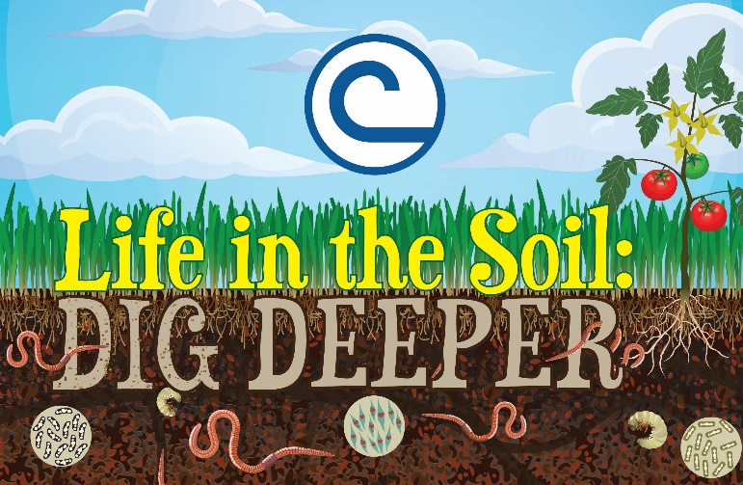
Duval Soil & Water Conservation District
2019 annual
Joe B. Forshee, Jr.
Speech Contest

TOPIC - "Life in the Soil: DIG DEEPER

March 6, 2019, 5:00pm
Duval County Extension Office
1010 N. Mc Duff Avenue
Jacksonville, FL

Entry Deadline: February 27, 2019

Eligibility: Public, Private, Home School students in 6th – 12th Grade in Duval County, FL

Purpose: To promote a greater appreciation for our natural resources; to develop Public Speaking and Leadership skills through participation in a public speaking activity; to stimulate interest in the conservation of our natural resources; and to expose students to the numerous career opportunities, in the Natural Resources and Environmental Sciences areas.

Special Note: The speech should address the above topic and shall be no more than 5 - 7 minutes long. Two points will be deducted for every 15 seconds less than or more than the allotted time. Research is required to develop the speech.

Awards: 1st place $ 50.00; 2nd place $ 30.00; 3rd place $ 20.00.
The first-place winner will represent the Duval SWCD regionally. If a winner there, that individual will represent our area statewide.

For additional information, go to www.duvalsoilandwater.com
Allen L. Moore @ 904-465-0678
amooresr@bellsouth.net

