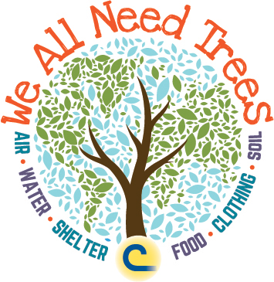

DUVAL SOIL AND WATER CONSERVATION DISTRICT
904-266-0088 ext. 114
2016 Speech Contest Topic
WHY DO WE ALL NEED TREES?
Location: 117 West Duval Street – Jacksonville, FL
Date: April 6, 2016

